Membership Application
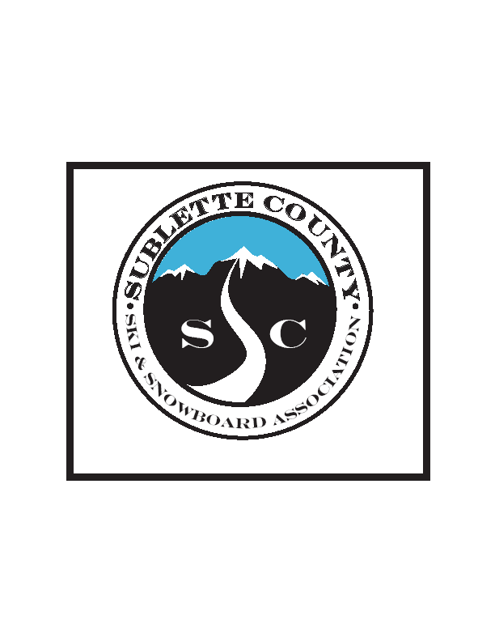Date________________________ Please make checks payable to SCSSA
$35.00
Check □
Cash □
Credit Card □

Sublette County Ski & Snowboard Association
P.O. Box 2033
Pinedale, WY 82941
sublettecountysnowsports.org
scssaclub@gmail.com

Member Name _________________________________________________________________

Email______________________________________________Cell Phone__________________

Mailing Address________________________________________________________________

_____________________________________________________________________________

Please consider volunteering

THIS SEASON NEXT SEASON
□ Volunteer coaching □ Membership Card
□ Sunny Korfanta GS □ 2020 Ski Swap
□ Flamingo Cup □ 2020 Warren Miller Film

□Would you like to be invited to club meetings?

WAIVER RELEASE
I, or my child, have (has) enrolled as a participant or member in the Sublette County Ski and Snowboard Association (SCSSA) programs and/or events voluntarily, and acknowledges and understand that the activities, programs and trips associated with the Sublette County Ski and Snowboard Association, such as skiing (Alpine or Nordic), snow shoeing, snowboarding, racing, training, travel, outing or activity and the like, hereinafter referred to as the “Events,” contain certain inherent foreseeable and unforeseeable risks of injury to me, or my child’s, person and/or property, such as, but not limited to, loss of control or falling, contact with unexpected or expected snow conditions or objects, both natural and manmade, and all other events or incidents related to the sport or skiing, which may result in loss of enjoyment of life, emotional distress, pain and suffering, disfigurement, physical or mental disability, loss of earnings or income, loss of consortium, loss of profits, loss of life, and all other claims and causes of action which could result from my child’s, participation in the events, hereinafter collectively referred to as the “Inherent Risks.” I also assume all risk in relation to such activity while participating on any outing or activity with the Sublette County Ski and Snowboard Association. I understand, and I am aware, that the Sublette County Ski and Snowboard Association trips are not led by professional guides. At the sole discretion of the trip or activity leader or coordinator, if my behavior is deemed to be dangerous to myself or others, I may be asked to leave the trip or activity, and I understand, and agree, that any cost incurred will be my sole responsibility and at my sole expense. I also acknowledge that the Sublette County Ski and Snowboard Association is a non-profit organization, and that all officers, directors, trustees, and volunteers are immune from civil liability for any act or omission resulting in damage or injury to any person, including myself, or my child.

Nevertheless, I, or my child, desire(s) to participate in the Sublette County Ski and Snowboard Association Events, and hereby assume the Inherent Risks of participating in the Events, and wave and release any and all claims that I, or my child, or the estate, family, heirs, and assigns, of myself, or my child may have, or could potentially arise, against the Sublette County Ski and Snowboard Association. Its officers, directors, trustees, coaches, and volunteers, as well as all claims brought against the Sublette County Ski and Snowboard Association, its officers, directors, trustees, and volunteers, as well as all owners and lessees of property where the programs and/or events are held, as a result of my, or
my child’s, own actions or missions.
Member Signature________________________________________________Date_________
Required
Parent Signature _________________________________________________ Date_________
If applicant is under 18 years old

